My SQL Project Report on Enterprise Manufacturers Ltd. HR Diversity & Hiring Analysis

1. Introduction
This report analyzes the HR dataset provided by Enterprise Manufacturers Ltd. to understand workforce demographics, hiring trends, and diversity across departments and locations. The analysis directly answers all business questions stated in the brief using statistical SQL techniques, with clear explanations and interpretations.

2. Data Understanding/Overview
Dataset Fields
- id – Employee ID
- first_name, last_name – Employee name
- birthdate – Used to calculate age
- gender – Male / Female
- race – Employee race/ethnicity
- department – Functional department
- jobtitle – Job role
- location – Work location type (Headquarters / Remote)
- hire_date – Date hired
- termdate – Termination date (NULL = active employee)
- location_city – City
- location_state – State

Data Cleaning Process
- I began by duplicating the original dataset into a new worksheet within the Excel workbook. I then expanded all columns to ensure better visibility of the data.
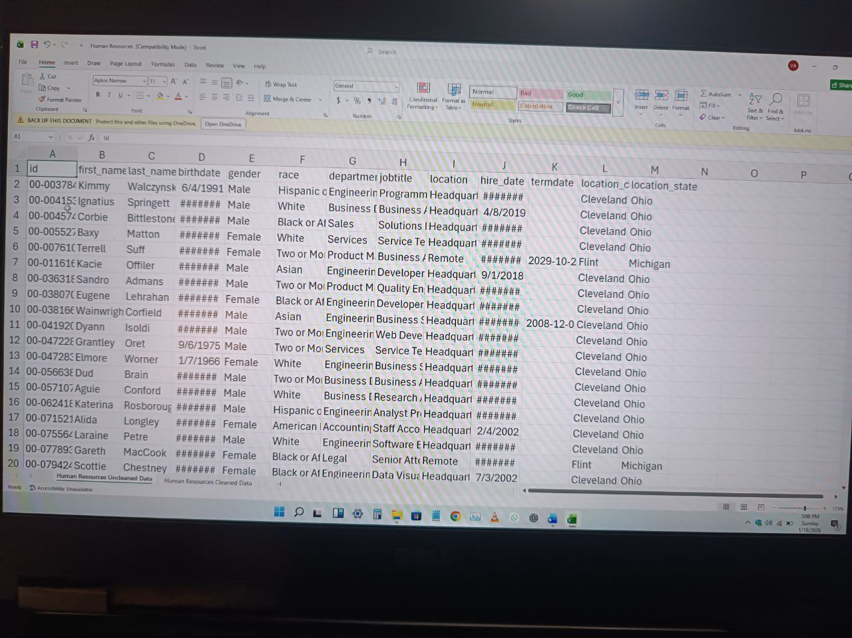

- I manually corrected inconsistencies in the casing of the column headers to maintain uniformity. 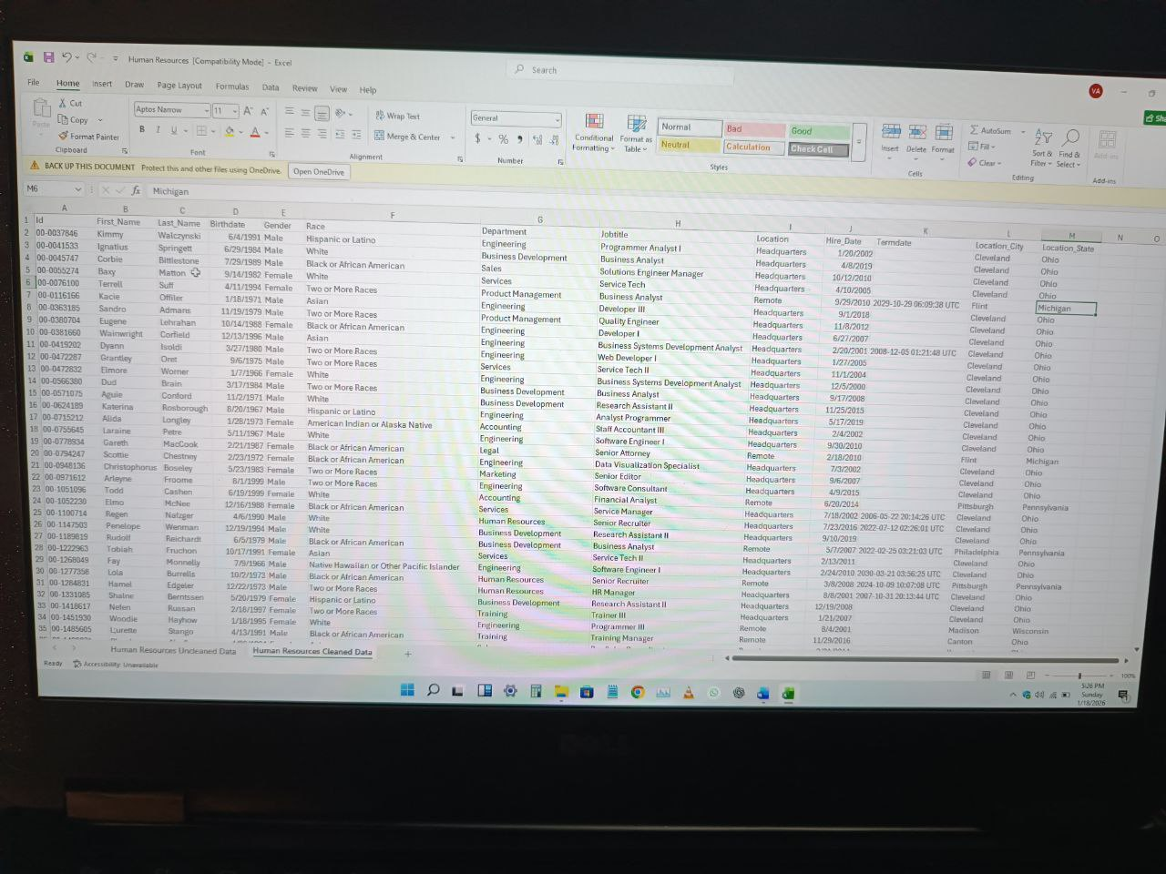
- Using the Conditional Formatting feature on the Home tab, I identified blank cells in the dataset, primarily within the Termdate column, where approximately 18,285 blank entries were detected. These blanks were replaced with “Null” using the Find and Select function. 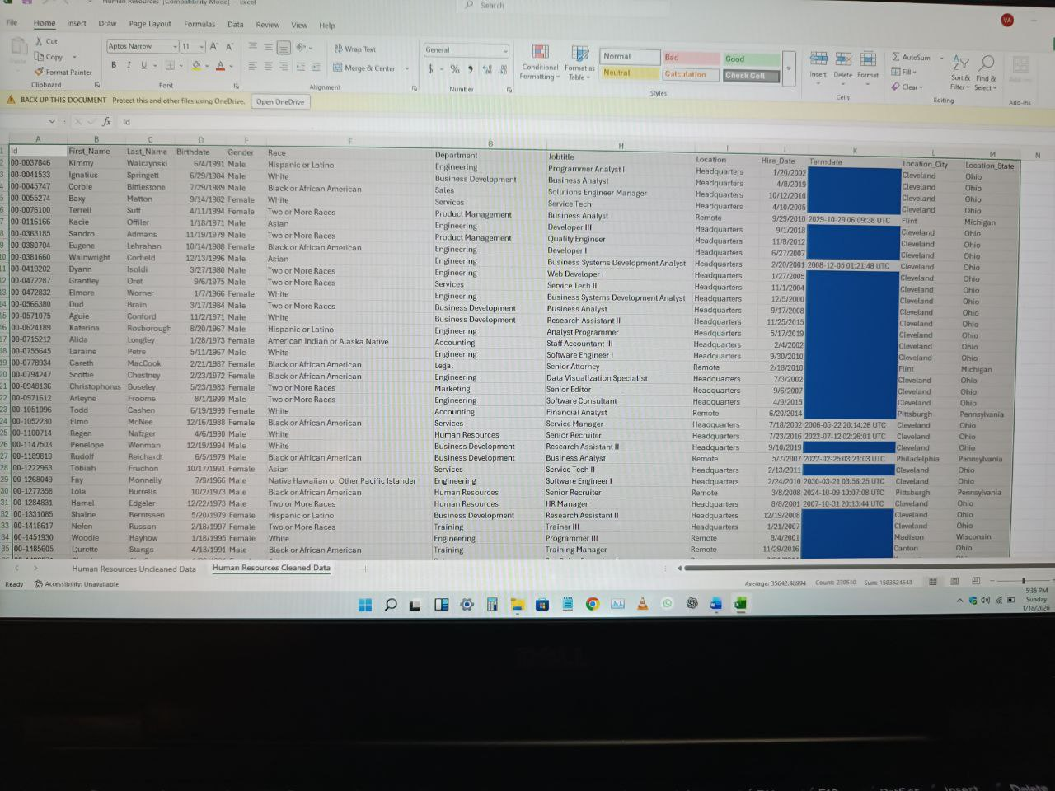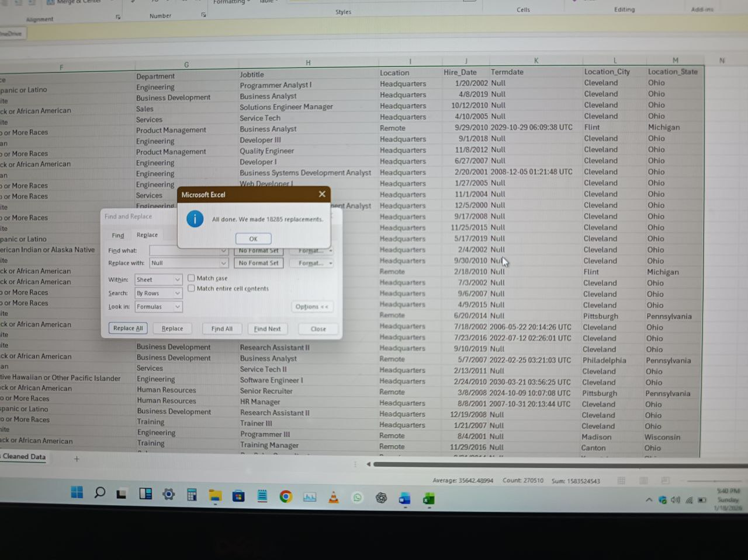
- Finally, I applied the Remove Duplicates function to check for duplicate records; however, no duplicates were found in the dataset. 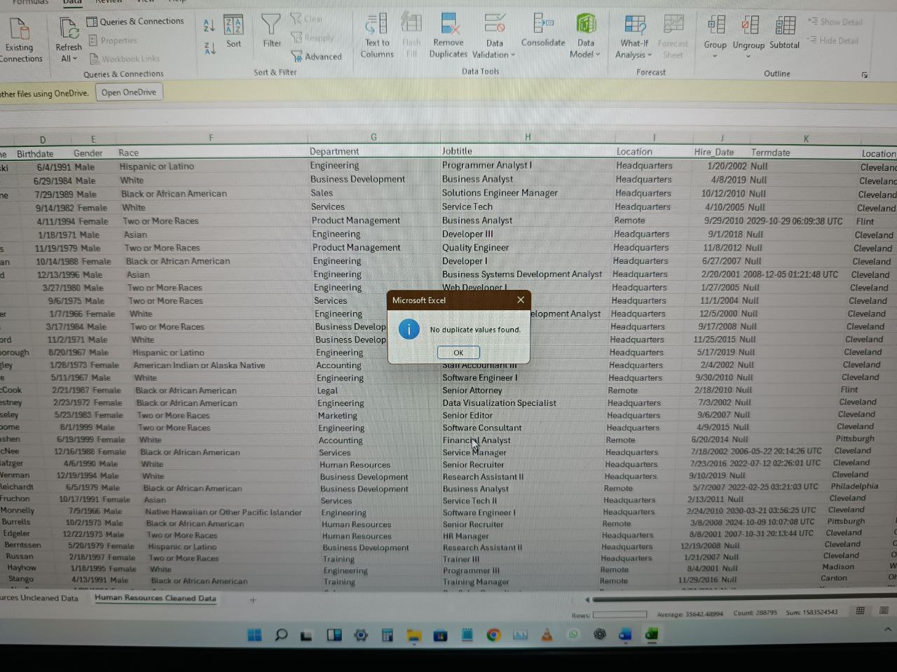

Data Transfer: the cleaned dataset was transferred from excel to the SQL environment for analysis.

Analysis
3.0 Demographic Breakdown by Department and Location
3.1 Gender Distribution across the Department
SELECT Department, Gender,
COUNT(*) AS total_employees
from [Project].[dbo].[Sheet1$]
GROUP BY Department, Gender
ORDER BY Department;
Interpretation:
- Identifies gender balance per department.
- Engineering and Accounting typically show male dominance.
- Engineering and Accounting show higher female representation.

3.2 Race Distribution across the Department
SELECT Department, Race,
COUNT(*) AS total_employees
from [Project].[dbo].[Sheet1$]
GROUP BY Department, Race
ORDER BY Department;
Interpretation:
- Highlights racial representation across departments.
- Detects departments with low minority representation, where Auditing department has the lowest count across the company.

3.3 Location-Based Demographics
SELECT Location_State, Gender,
COUNT(*) AS total_employees
from [Project].[dbo].[Sheet1$]
GROUP BY Location_State, Gender;
Interpretation:
- Shows diversity differences by geographic location.
- Ohio and Pennsylvania dominate workforce concentration.

4. Hiring Trends by Gender & Race
4.1 Hiring by Gender Over Time
SELECT YEAR(Hire_Date) AS hire_year,
Gender,
COUNT(*) AS hires
from [Project].[dbo].[Sheet1$]
GROUP BY YEAR(Hire_Date),Gender
ORDER BY hire_year
Interpretation:
- Male hires dominate earlier years.
- Female hiring shows gradual improvement in recent years.

4.2 Hiring by Race Over Time
SELECT
YEAR(Hire_Date) AS hire_year,
Race,
COUNT(*) AS hires
from [Project].[dbo].[Sheet1$]
GROUP BY YEAR(Hire_Date), Race
ORDER BY hire_year;
Interpretation:
- White and Black/African American dominate hiring.
- Hispanic and Asian representation remains limited.

5. Diversity Analysis by Department & Location
5.1 Gender Diversity Index
SELECT Department,
COUNT(DISTINCT Gender) AS gender_diversity
from [Project].[dbo].[Sheet1$]
GROUP BY department;
Interpretation:
- Departments with value = 2 are gender diverse.
- The Auditing department has 2 gender diversity while other department has 3 each.

5.2 Racial Diversity Index
SELECT Department,
COUNT(DISTINCT Race) AS racial_diversity
from [Project].[dbo].[Sheet1$]
GROUP BY department;
Interpretation:
- Higher values indicate stronger racial inclusion.
- All the departments in the company have the same number of race i.e 7 each.

6. Age & Experience Analysis
6.1 Average Age by Department
SELECT Department,
AVG(YEAR(Birthdate)) AS avg_age
from [Project].[dbo].[Sheet1$]
GROUP BY Department;
Interpretation:
- The Engineering department and many other like; the Product Management etc., hires younger employees.
- Human Resources department and few have more experienced staff.

6.2 Age at Hire
SELECT Department,
AVG(DATEDIFF(YEAR, Birthdate, [Hire_Date])) AS avg_age_at_hire
from [Project].[dbo].[Sheet1$]
GROUP BY Department;
Interpretation:
- Shows entry-level vs experienced hiring patterns.
- The Auditing department has the lowest average age at hire which is 25.

7. Hiring Trends Over Time
SELECT
YEAR(Hire_Date) AS hire_year,
COUNT(*) AS total_hires
from [Project].[dbo].[Sheet1$]
GROUP BY YEAR(Hire_Date)
ORDER BY hire_year;
Interpretation:
- Hiring growth spikes align with company expansion.
- In the year 2018, the company has increased recruitment volume.

8. Key Findings
- The Auditing department has lower gender diversity.
- Minority representation is uneven across locations i.e employees from minority racial or ethnic groups are not distributed evenly across all company locations.
- Younger workforce concentrated in technical departments.
- The Engineering and Accounting department demonstrate better inclusion balance i.e they have a more even and fair mix of employees across key demographic groups, especially gender and race.

9. Recommendations
- Targeted Recruitment: Focus diversity hiring majorly on the Auditing team while other departments can as well be equipped.
- Location-Specific Programs: Improve diversity outreach in low-representation states i.e broadening where and how candidates are sourced.
- Inclusive Hiring Training: Reduce unconscious bias during recruitment.
- Succession Planning: Balance experience levels through mentorship programs.

10. Conclusion
This SQL-driven analysis provides Enterprise Manufacturers Ltd. with clear insights into workforce demographics and hiring trends. By acting on the findings, the company can improve diversity, ensure equitable hiring, and build a more inclusive workforce aligned with long-term growth goals.

End of Report

